** THE MONEY TREE**

**(A Personal Finance and Investment Application)**

**Capstone Project Proposal**

**Submitted by:**

**101603051 Arham Bansal**

**101603050 Archit Puri**

**101603001 Aarush Chopra**

**101611029 Kartik Ramsanghaney**

**BE Third Year, COE**

**CPG No. 135**

Under the Mentorship of

**Ms. Rajanpreet Kaur Chahal**

(Lecturer)



**Computer Science and Engineering Department**

**Thapar Institute of Engineering and Technology, Patiala**

**March & 2019**

**TABLE OF CONTENTS**

Mentor Consent Form 3

Project Overview 4

Need Analysis and Problem Statement 5

Literature Survey 6

Assumptions and Constraints 9

Standards 9

Objectives 10

Methodology 10

Work Plan 11

Project Outcomes & Individual Roles 12

Course Subjects 13

References 14

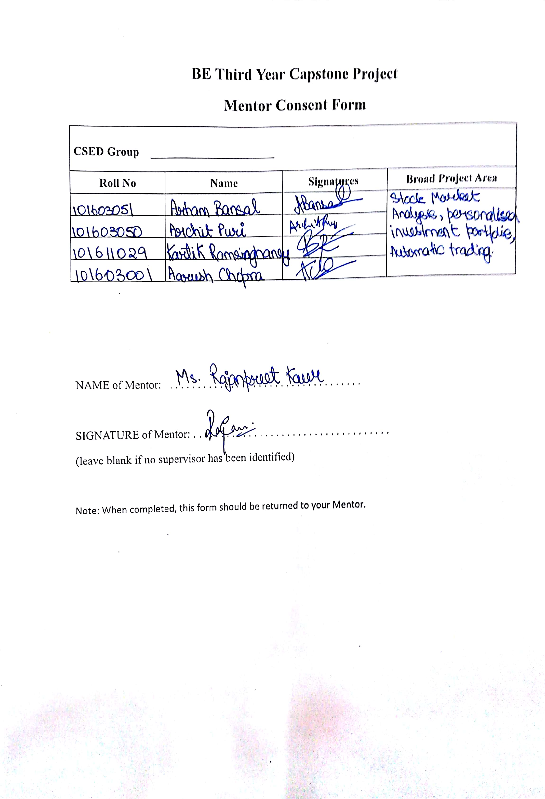

# Project Overview

Our project, ***The Money Tree***, is a stock market investment and personal finance management platform for the common man. Here we intend to build a platform, which would help users in curating risk-optimized portfolios by simply filling up a risk analysis survey form.

The major objective of investors is to maximize their expected return and reducing its related risks (Hejazi and Oskouei, 2007). In order to maximize the returns of investors, Graham and Dodd (1934) developed a few sound principles for analyzing a company's fundamentals and its future scenario. They revolutionized the investment theory by introducing the concept of security analysis, fundamental analysis, and value investing theory.

We aim at providing customized investment opportunities based on the users' risk appetite and future goals to maximize profits, minimize risks and save tax by quantifying the principles laid out by Graham and Dodd to ultimately automate the process for stock selection.

# 

# Need Analysis and Problem Statement

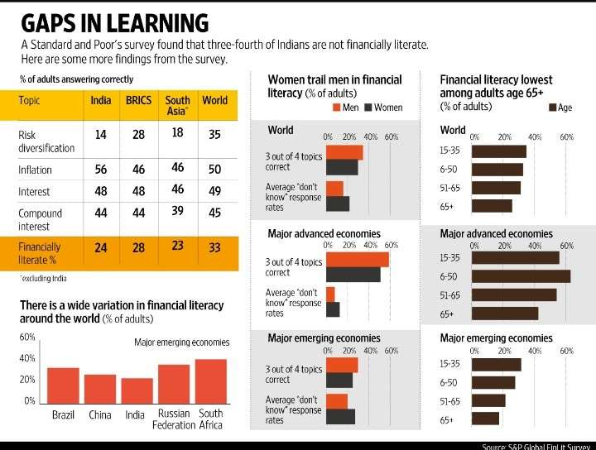**THE PROBLEM**

Figure 1. Financial Literacy Survey

A Standards and Poor Survey found out that three-fourths of the Indians are financially illiterate and hence neither do they understand how financial markets work nor do they know the importance of financial investment. Most of the Indians also do not prefer to hire professionals due to high commission fees.

Hence, end up not investing at all or investing in the wrong places.

**WHY INVEST & THE NEED**

Before we address the above question, let us understand what would happen if one chooses not to invest. Let us assume you earn Rs.50,000/- per month and you spend Rs.30,000/-towards your cost of living which includes housing, food, transport, shopping, medical etc. The balance of Rs.20,000/- is your monthly surplus. After 20 years of hard work, you have accumulated Rs.1.7Crs.

Let’s consider another scenario where instead of keeping the cash idle, you choose to invest the cash in an investment option that grows at let’s say 12% per annum. For example – in the first year you retained Rs.240,000/- which when invested at 12% per annum for 20 years yields Rs.2,067,063/- at the end of 20th year.

But with the decision to invest the surplus cash, your cash balance has increased significantly. The cash balance has grown to Rs.4.26Crs from Rs.1.7Crs. This is a staggering 2.4x time the regular amount. This translates to you being in a much better situation to deal with your post-retirement life.

Now, going back to the initial question of why invest? There are a few compelling reasons for one to invest.

1. Fight Inflation – By investing one can deal better with the inevitable – growing cost of living – **generally referred to as Inflation**
2. Create Wealth – By investing one can aim to have a better corpus **by the end of the defined time period.** In the above example, the time period was retirement but it can be anything – children’s education, marriage, house purchase, retirement holidays etc
3. To meet life’s financial aspiration.

# Literature Survey

1. **Security Analysis: Sixth Edition, Foreword by Warren Buffett**: Security Analysis provided us with an invaluable roadmap to navigate through unpredictable, often volatile, and sometimes treacherous financial markets. Value investing, today as in the era of Graham and Dodd, is the practice of purchasing securities or assets for less than they are worth—the proverbial dollar for 50 cents. Investing in bargain-priced securities provides a “margin of safety”—room for error, imprecision, bad luck, or the vicissitudes of the economy and stock market. As Graham has instructed, those who view the market as a weighing machine—a precise and efficient assessor of value—are part of the emotionally driven herd. Those who regard the market as a voting machine— a sentiment-driven popularity contest—will be well positioned to take proper advantage of the extremes of market sentiment.
2. **The Intelligent Investor: The Definitive Book on Value Investing. By Benjamin Graham** - Graham's philosophy of "value investing" -- which shields investors from substantial error and teaches them to develop long-term strategies -- has made The Intelligent Investor the stock market bible ever since its original publication in 1949.
3. **The Warren Buffett Way by Robert G. Hagstrom**: This book explores the forethought of a man who commenced his entrepreneurial ambitions with a mere 100 dollars in his pocket and ended up building a $20 billion empire. Robert closely studied Warren Buffett’s actions, words, and decisions for a number of years, and then set about analyzing them for common threads. For this book, he distilled those common threads into twelve tenets, timeless principles that guide Buffett’s investment philosophy through all circumstances and all markets. In just the same way, they can guide any investor.
4. **Investor profile questionnaire by Charles Schwab**. : Find a suitable investment strategy Your investing strategy should reflect the kind of investor you are—your personal investor profile. This quiz will help you determine your profile and then match it to an investment strategy that’s designed for investors like you. The quiz measures two key factors:
   1. **Your Time Horizon:** When will you begin withdrawing money from your account and at what rate? If it’s many years away, there may be more time to weather the market’s inevitable ups and downs and you may be comfortable with a portfolio that has a greater potential for appreciation and a higher level of risk.
   2. **Your Risk Tolerance:** How do you feel about risk? Some investments fluctuate more dramatically in value than others but may have the potential for higher returns. It’s important to select investments that fit within your level of tolerance for this risk.
5. **A Beginner’s Guide to Learn Algorithmic Trading by QuantInsti®**: Algorithmic trading (automated trading, black-box trading, or simply algo-trading) is the process of using computers programmed to follow a defined set of instructions for placing a trade in order to generate profits at a speed and frequency that is impossible for a human trader. Before we take you through any further details, here’s a light read on how algo trading can make your life easier.

**Existing Systems -**

Some of the existing systems, which provide insights but not customized suggestions to the user.

1. **Screener.in**

Screener.in a stock screening and analysis tool that displays information about companies listed on the stock exchanges in India. You can search for any company by just typing the name in the search box. The screener displays the chart, financial statements, analyst reviews, peer comparison, and reports for any company you search.

1. **Trendlyne**

Platform for all stock market news and indicators. One can find fundamental as well as technical indicators on the website. They have built stock screeners that can be used to make profitable trades in the market

1. **MoneyWorks4me**

MoneyWorks4me is a unique portal that is developed for empowering retail investors by providing equity research and stock recommendations. They have developed a screener tool that helps investors to find stocks based on certain pre-defined criteria.

1. **Equity Boss**

Edelweiss Broking Ltd is one of the leading broking houses. The customers can trade in equity, derivatives, etc. They have built a stock screener which can be used to find stocks based on pre-defined or your own criteria

# Assumptions and Constraints

**Assumptions:**

1. Continuous data availability from 3rd party sources
2. Honesty of user
3. Bearish behavior
4. Commissions and adverts

**Constraints:**

1. Data delay
2. Government regulations
3. Data insufficiency
4. Intra-day trading

# Standards

The following Standards will be followed:

1. **IEEE Standard 829** - IEEE Standard for Software and System Test Documentation.
2. **IEEE Standard 830** - IEEE Recommended Practice for Software Requirements Specifications.
3. **IEEE Standard 1008** - IEEE Standard for Software Unit Testing.
4. PNG 1.2
5. My Sql 8.0 - For Database Management.
6. Android Sdk 16 - Min Android Sdk Support.
7. Spring Framework 2.0
8. Python 3.7.1

# Objectives

1. Building and analyzing the risk profile of the user.
2. Analysis of specific categories of stocks.
3. Custom stock portfolio recommendation based on the risk profile.
4. Tax saving recommendations based on the personal profile.
5. Developing an android/Web application as a user interface

# Methodology

**Step - 1 Data Collection:**

We intend to collect Financial Data from **Quandl**. This data will have complete historical data of both BSE and NSE listed stocks. The data would processed further for technical & fundamental analysis of a stock.

**Step - 2 Data Analysis:**

1. **Risk Analysis**

To propose investments that fits within a user’s level of tolerance for risk, we will develop a questionnaire with basic, easy to interpret questions.

Answering these questions, the user will get a basic automatically calculated risk analysis data. User can edit this data if required. This data will further be used for stock recommendations calculations.

1. **Stock Analysis**

* We will filter the top 50 companies by market cap
* We will find the top two sectors that have the highest average PE ratio and other criterions.
* Using various valuation parameters, we will pick out the top sector stocks.

The system will then generate custom recommendations for the user.

**Step - 3 User Interface:**

We plan to create an easy to use android/web application for any commoner to use services provided by us.

# Work Plan

The following figure represents the work breakdown structure of the whole project. The work plan has three main categories – the frontend, the backend, and the data collection unit.

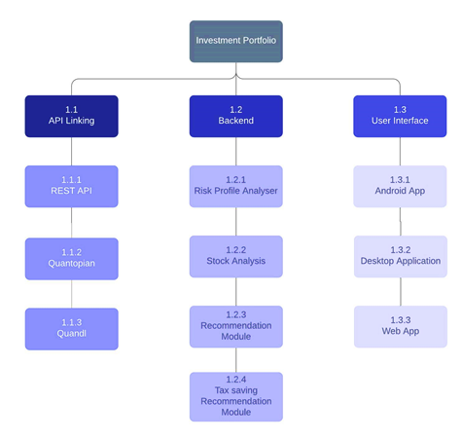

Figure 2. Work Plan Structure

# Project Outcomes & Individual Roles

A user-friendly Android/Web Application for personalized/family financial management. Recommendations for various investment options available in the market providing above average returns as well as Tax benefits.

**Table 1. Individual Roles**

|  |  |
| --- | --- |
| NAME | ROLE |
| Arham Bansal  (Python Developer, Stock Market Analyst) | * + - 1. Project Leader       2. Developing Algorithm for Stock Market Analysis and Recommendation using Python in Quantopian Notebook Environment.       3. Historical Data Analysis       4. Background Research       5. Project Integration |
| Archit Puri  (Java Core Developer, Stock Market Enthusiast) | Rest Api Development using Spring Java Framework  Developing Tax Saving Strategies.  Android Application Deployment  Project Deployment  Project Integration |
| Aarush Chopra  (Python Developer, Data Analyst) | Personalized Risk Profile Analysis using Python   1. Developing and Quantifying Risk Analysis survey using Machine Learning Tools. 2. Integrating Risk analysis Data with recommendation Algorithm. 3. Project Integration |
| Kartik Ramsinghaney  (Java Developer, Data Analyst) | Risk Profile Analysis using Python/Java  Desktop User Interface Development.  Visualization and GUI Development  GUI and Overall Project Integration |

# 

# Course Subjects

1. Software Engineering
2. Operating System - (Deployment Of Application)
3. Database Management System
4. Data Structures
5. Java
6. Data Analytics and Visualization
7. Machine Learning
8. Optimization Techniques
9. Discrete Mathematics
10. Python

# 

# References

1. ©2018 Charles Schwab & Co., Inc. (“Schwab”). All rights reserved. Member SIPC. (1018-8X5W) MKT25657-13 (09/16). Source: Schwab Center for Financial Research with data provided by Morningstar, Inc.
2. Graham, Dodd, Cottle, Murray, Block, & Leibowitz: Security Analysis, Fifth Edition (1988). Copyright © 2009, 1988, 1962, 1951, 1940, 1934 by The McGraw-Hill Companies, Inc. DOI: 10.1036/0071592539
3. A Beginner’s Guide to Learn Algorithmic Trading. Copyright © 2018 QuantInsti.com All Rights Reserved.
4. Stock markets, trading, and investments – Simplified. Varsity by Zerodha © 2015 – 2019. All rights reserved.
5. The Warren Buffet Way. Copyright © 2005 by Robert G. Hagstrom. All rights reserved. Published by John Wiley & Sons, Inc., Hoboken, New Jersey. ISBN 0-471-64811-6
6. [Graham, Benjamin](https://en.wikipedia.org/wiki/Benjamin_Graham); Jason Zweig (2003-07-08) [1949]. The Intelligent Investor. Warren E. Buffett (collaborator) (2003 ed.). [HarperCollins](https://en.wikipedia.org/wiki/HarperCollins). front cover. [ISBN](https://en.wikipedia.org/wiki/International_Standard_Book_Number) 0-06-055566-1
7. Quandl: Financial, Economic and Alternative Data